|  |  |  |
| --- | --- | --- |
| **CL-1002 Programming Fundamentals** | **LAB – 02**  **Problem solving with decision and iterative structures using Scratch** | |
| **NATIONAL UNIVERSITY OF COMPUTER AND EMERGING SCIENCES**  **Fall 2021**  **NATIONAL UNIVERSITY OF COMPUTER AND EMERGING SCIENCES**  **NATIONAL UNIVERSITY OF COMPUTER AND EMERGING SCIENCES**  **NATIONAL UNIVERSITY OF COMPUTER AND EMERGING SCIENCES** | |  |

**Introduction to Decision and Iterative Structures**

**Decision Structure:** A statement or a set of statements that is executed when a particular condition is “True” and ignored when the condition is “False”.

In scratch, we use the following control diagrams for decision structure.

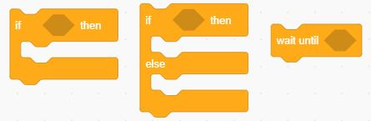

***Example 01***: Given a number as an input by a user, check if the number is a negative number or a positive number.

|  |  |  |
| --- | --- | --- |
| **Flowchart of Decision Structure** | **Scratch Diagram** | **Output** |
|  |  |  |

**Iterative Structure:** The statements that cause a set of statements to be executed repeatedly either for a specific number of times or until some condition is satisfied are known as **iteration statements.**

In scratch, we use the following control diagrams for iterative structures:

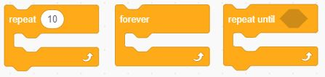

***Example 02:*** Set a counter to 1 and repeat until the given condition is satisfied. In this case, the given condition is counter =10.

|  |  |  |
| --- | --- | --- |
| **Flowchart of Iterative Structure** | **Scratch Diagram** | **Output** |
|  |  |  |

***Example 03:*** Draw a pentagon with the help of repeat and pen diagrams. Repeat the shape for five times.

|  |  |
| --- | --- |
| **Scratch Diagram** | **Output** |
|  |  |

**Exercise Questions**

**QUESTION # 1:** Take a number as an input from a user. Check if the number is an even number or an odd number. Draw a flowchart on your notebook. Convert the flowchart into scratch diagram.

**QUESTION # 2:** You are supposed to create a mark sheet. There are total five subjects. Each subject has equal marks i.e., 100, therefore total marks are 500. Take marks of five subjects as an input from the user. Calculate the percentage. If the percentage is below 50, he/she is fail else he/she is pass. Draw a flowchart on your notebook. Convert the flowchart into scratch diagram.

**QUESTION # 3:** Draw a hexagon that has six sides. Repeat the hexagon for the same number of times as of its size.

**QUESTION # 4:** Given below is a flow chart. Identify the decision and iterative structures in it. Convert the flow chart in to scratch diagram.

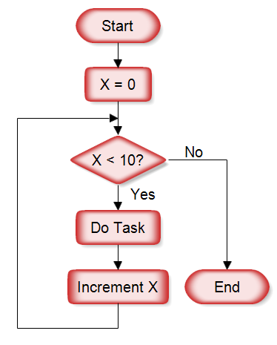

**QUESTION # 5:** Given below is a scratch diagram. Write a description of the diagram as well as draw it’s flowchart on your notebook.

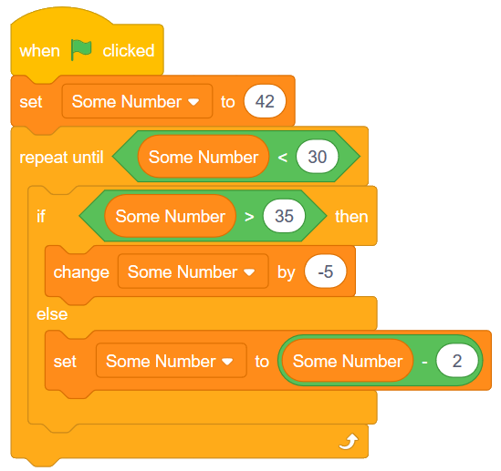

Good Luck ☺